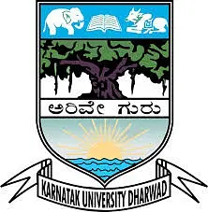

KARNATAK UNVIRSITY DHARWAD

ANJUMAN INSTITUTE OF INFORMATION SCIENCE AND MANAGEMENT,DHARWAD

BACHELOR OF COMPUTER APPLICATIONS

VI SEMISTER

-:PROJECT REPORT ON:-

“BOOK YOUR LAPTOP”

UNDER THE GUIDENCE OF

PROF: A.M KITTUR

SUBMITED BY

MOHAMMAD ZUBER SAGAR

20U10218